Upon opening the WxApp, you will see some simple text that explains the user options.

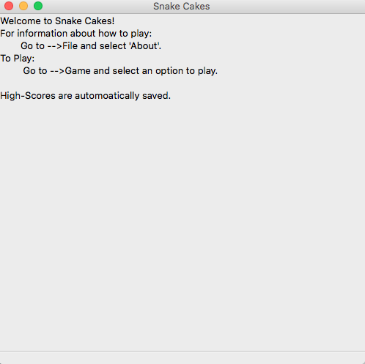

Hovering over the “About” button on the File menubar shows the how-to functionality

Clicking opens this Message Dialog:

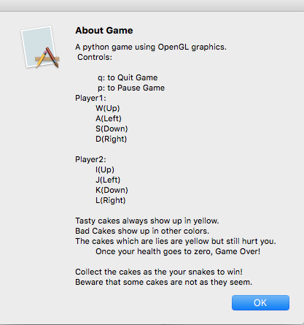

Now for the Game Starting:

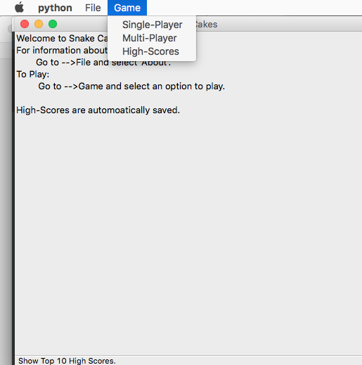

Clicking on Single-Player prompts user for name:

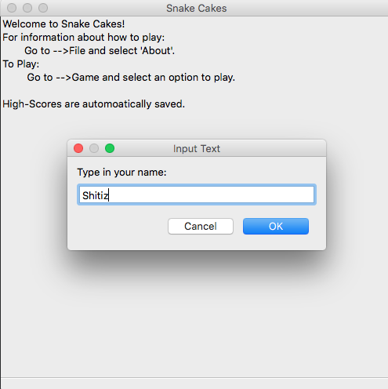

After clicking ok, the game starts.

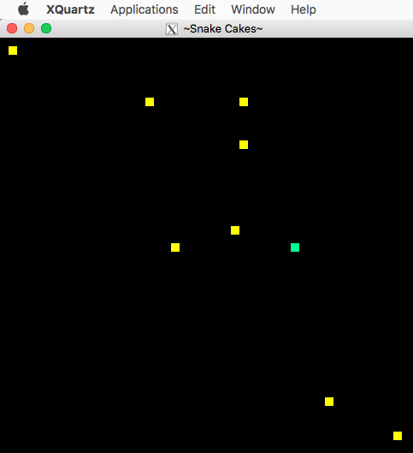

Clicking on High Scores in Game menu pops up a top-scores message box.

